# **MOST POPULAR PROGRAMMING LANGUAGES**

Pretty much sure, almost everyone knows that in today’s digitally advanced world how technology is changing at a rapid pace. It has become quite normal to watch alternative technologies surpassing each other frequently with regular updates & advancements. Amidst all this, there comes a domain that gets affected a lot with such a volatile nature of the tech world – *and that is Programming Language!*

Knowing a programming language is essential for many high-tech jobs, such as those in the fields of data science and software engineering. A question people often ask when considering a new career that involves technology is “which programming language(s) should I learn?”

## **THE BIG TOP 10**

* Javascript
* Python
* Java
* C
* PHP
* C#
* Swift
* Rust
* Elm
* Ruby

### **Javascript**

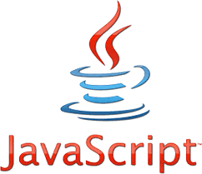

JavaScript is a [programming language](https://techterms.com/definition/programming_language) commonly used in [web development](https://techterms.com/definition/web_development). It was originally developed by Netscape as a means to add dynamic and interactive elements to websites. Many languages came and disappear but JavaScript is one of those few renowned languages that is enjoying a high run and demand in the programming world. Though the language is primarily known for adding responsive elements on web pages it has a wide range of applications such as in web development, game development, mobile application development, and many more. Plus JavaScript is primarily a front-end language run on the browser, it can also be used on the server-side through Node.js to build scalable network applications. Node.js is compatible with Linux, SunOS, Mac OS X, and Windows.

Along with HTML and CSS, JavaScript is essential to front-end web development.

Meanwhile, some of the renowned companies in the tech world that are using JavaScript are Facebook**, Google, Microsoft, Uber,** etc.

It’s impossible to be a software developer these days without using JavaScript in some way. According to Stack Overflow's [2020 Developer Survey](https://insights.stackoverflow.com/survey/2020), JavaScript is the most popular language among developers for the eighth year in a row. Nearly 70 percent of survey respondents reported that they had used JavaScript in the past year.

As there are millions of websites already existing over the web that are heavily relying on JavaScript and on top of that, looking at the demand & dominance of the language, it won’t be wrong to say that JavaScript will rule in 2021 as well!

### **Python**

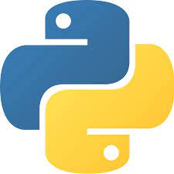

Python is perhaps the most user-friendly programming language of any on this list. It’s often said that Python’s syntax is clear, intuitive, and almost English-like, which, like Java, makes it a popular choice for beginners. As per the **RedMonk Ranking** report for the year 2020, [**Python outranks JAVA**](https://redmonk.com/sogrady/2020/07/27/language-rankings-6-20/) (Its greatest competitor) to become the second most popular programming language. The language has experienced tremendous growth of around **18-19%** in the last 5 years.

The language is extensively used for web development, software development, etc., and with several trending technologies such as Machine Learning, Artificial Intelligence, Data Science, etc. The language offers some enriching features such as rich library support, automatic garbage collection, easier integration with other languages, GUI Programming support, and many more.

Also like Java, Python has a variety of applications that make it a versatile, powerful option when choosing the best programming language for your use case.  If you’re interested in back-end web development, for example, then the open-source Django framework, written in Python, is popular, easy to learn, and feature-rich.

### **Java**

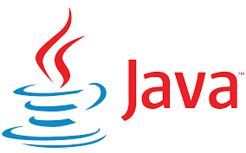

Many times it seems out that JAVA is losing its charm but when we look at the actual stats – every year JAVA ends up with a really good ranking that proves the particular language is still doing well and in-demand in the tech world. There are around **8 million JAVA developers** across the world – maybe this number can help you to assess the demand & popularity of this particular language.

Java’s popularity is for good reason; this language is relatively [easy to learn and use](https://bootcamp.berkeley.edu/blog/best-way-to-learn-java/), boasts incredible security and can handle massive amounts of data. These features make Java an ideal language for the online finance sector, and it is often applied in industries such as banking, billing and the stock market.

The versatility of the language, however, is what learners find really appealing. Touted as a “write-once, run-anywhere” language, Java can effectively run on *any* operating system, regardless of which OS was used to write the original code. It is thus ideal for writing apps not only for mobile phones and computers, but also remote processors, sensors and a variety of other consumer products.

### [**C**](https://www.geeksforgeeks.org/c-programming-language/)**/**[**C++**](https://www.geeksforgeeks.org/c-plus-plus/)

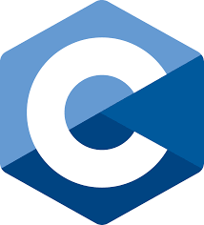 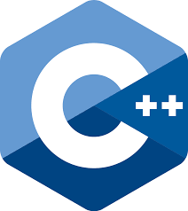

As we know both C and C++ are programming languages and used for application development. The main difference between both these languages is C is a procedural programming language and does not support classes and objects, while C++ is a combination of both procedural and object-oriented programming languages.

Both C and C++ are occupying a considerable portion of the tech world and currently ranking at the top positions on various indexes.

There are numerous big tech companies that hire C/C++ developers with some decent salary packages such as **Adobe, Oracle, Microsoft, Nvidia,** etc. And to learn C/C++ in 2021 is not only beneficial from the career perspectives but it also somehow makes it easier for you to learn other programming languages afterward.  On the other hand, C++ is an object-oriented programming language (primarily developed as an extension of C). The language is widely used in Game Development, GUI & Desktop applications, and Competitive Programming along with several other fields.

If we particularly talk about C language, the general-purpose procedural programming language is majorly used in the development of low-level systems like operating systems, kernel development, and others. And many other programming languages inherit the properties of this particular language.

### **PHP**

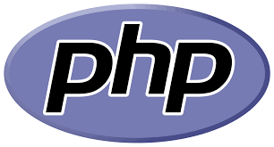

Like many others, if you’re also considering that PHP is not worth it to learn in 2021 then you must know that the language is still doing very well in the tech world and is being preferred by the developers. The open-source server-side scripting language is used for the website development and comes up with some prominent features like cross-platform compatibility, object-oriented programming features, easy integration with HTML, CSS, JavaScript, etc., huge community support, and many more. The language is strongly recommended to beginners as it is quite easier to learn. Some of the popular PHP frameworks that you can take into consideration are Laravel, Symfony, CodeIgniter, etc. So, if you’re particularly looking forward to getting into the web development domain, PHP would be a great choice for you!

### **Rust**

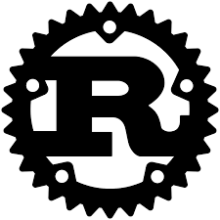

Rust is a bit of an upstart among the other languages on this list, but that doesn’t mean it’s not a valuable language to learn. Stack Overflow’s [2020 Developer Survey](https://insights.stackoverflow.com/survey/2020#technology-most-loved-dreaded-and-wanted-languages) found that Rust was the most loved programming language among developers for the fifth year in a row, with 86.1 percent of Rust developers saying that they want to continue working with it. The advantages of Rust mean that other big tech companies, such as Dropbox and Coursera, are already starting to use it internally.

While it may be a bit more difficult to master than other beginner languages, Rust programming skills are likely to pay off handsomely, as the language's popularity will only continue to rise in the near future. Developed by the Mozilla Corporation, Rust, like C and C++, is intended primarily for low-level systems programming. What Rust adds to the mix, however, is an emphasis on speed and security. Rust emphasizes writing “safe code” by preventing programs from accessing parts of memory that they shouldn’t, which can cause unexpected behavior and system crashes.

### **Ruby**

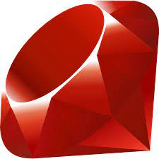

Ruby is another scripting language that’s commonly used for web development. In particular, it’s used as the basis for the popular Ruby on Rails web application framework. In addition to the active community and its straightforward syntax, Ruby is also a good language to pick up thanks to its association with great tech businesses.

Twitter, Airbnb, Bloomberg, Shopify, and countless other startups have all built their websites using Ruby on Rails at some point. Beginners often gravitate toward Ruby because it has a reputation for having one of the friendliest and most helpful user communities. The Ruby community even has an unofficial saying, “Matz is nice and so we are nice,” encouraging members to model their kind and considerate behavior on Ruby’s chief inventor Yukihiro Matsumoto.

### **Swift**

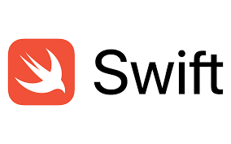

If you’re interested in Apple products and mobile app development, Swift is a good place to start. First announced by Apple in 2014, Swift is a relatively new programming language used to develop iOS and macOS applications.

Swift has been optimized for performance and built from the ground up to match the realities of modern iOS development. Not only does iOS run on every iPhone and iPad, but it’s also the basis for other operating systems such as watchOS (for Apple Watches) and tvOS (for Apple TVs). In addition, Apple isn't going anywhere as a tech industry leader, and iOS apps continue to be the most profitable in the mobile app marketplace.

### **Elm**



One of the youngest languages on our list, what began as a Harvard student’s thesis has now grown to become a point of passion for front-end developers around the world.

Elm compiles to JavaScript, making it ideal for building fast-executing UIs with zero errors at runtime. Elm is a functional programming language, allowing developers to create client-side interfaces without the declarative trappings of HTML and CSS.

Furthermore, the Elm web architecture was the intellectual inspiration for Redux, the state-management library taught here at Fullstack.

### **C#**

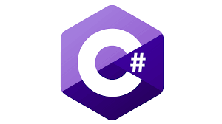

For the last many years, C# is holding a good position in the list of top programming languages of almost every index. The general-purpose programming language is developed by Microsoft primarily for its .Net framework. The language is extensively used for game development along with the development of Windows applications, server-side applications, etc. Moreover, C# comes up with a rich set of libraries that makes it a faster and efficient programming language. Some of the remarkable features of the language that are often appreciated by the developers are – structured language, faster compilation, updateable & scalable, component-oriented, complete integration with .NET library, and many more.

The language is being used in Unity game engine software consistently by the developers and companies like Intellectsoft, Capgemini, etc. are also using C# for the businesses – it signifies that job opportunities for C# developers in the market are also satisfactory. So, if you’re looking forward to learning C# in 2021, you can go for it without giving a second thought!